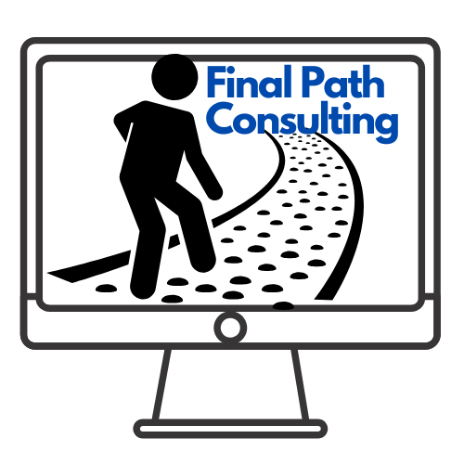

Lessons learned

* As a team throughout the semester, we have learned how to improve our communication. At the beginning of the project, there was a lack of communication where not all team members were responsive in the group chat and not everyone was stating their issues. However, the lack of communication caused several members to submit deliverables in the wrong format or with incomplete information. We had a group meeting before starting phase 2 and realized that few team members did not have a proper understanding of our project’s overall scope and due to them not having complete details, they were submitting wrong formatted and incorrect deliverables. After realizing that issue, we worked together as a team to come up with an effective form of communication and came to the conclusion that we need to be more consistent with our weekly meetings every week and everyone was asked to not hesitate in asking questions from their team and if they need any sort of help.
* Another lesson that we have learned as a team is to use the professor’s given deliverables rubric to properly format each deliverable. Earlier in the semester, our team was confused about how to format their individual deliverables. However, After talking to our project manager and professor, we realized that the deliverables rubric was supposed to assist in formatting each document.
* Due to COVID 19, our team had to adapt to how to work from home on our project with no face to face interaction. In the beginning, it was a bit complicated to adjust to such sudden change, however through the use of Microsoft TEAMS, our team soon adjusted to this change by scheduling weekly meetings on Microsoft teams instead of face to face.